Social media productivity dataset

Dataset before cleaning :
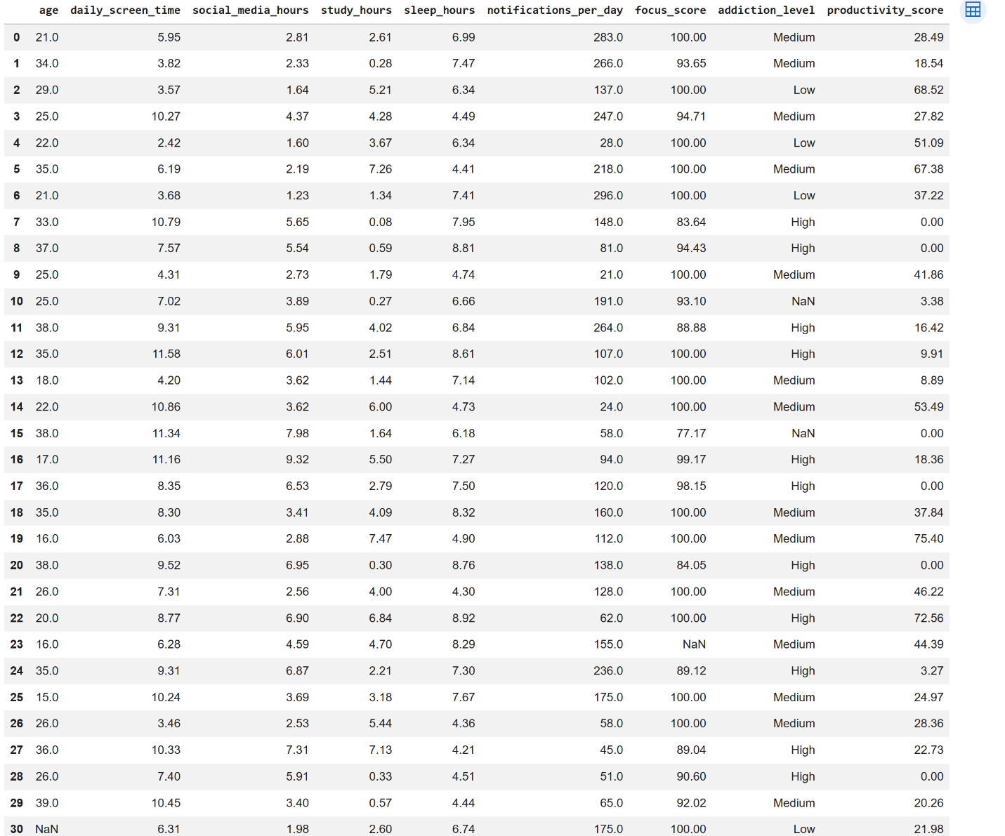

Dataset after cleaning :
